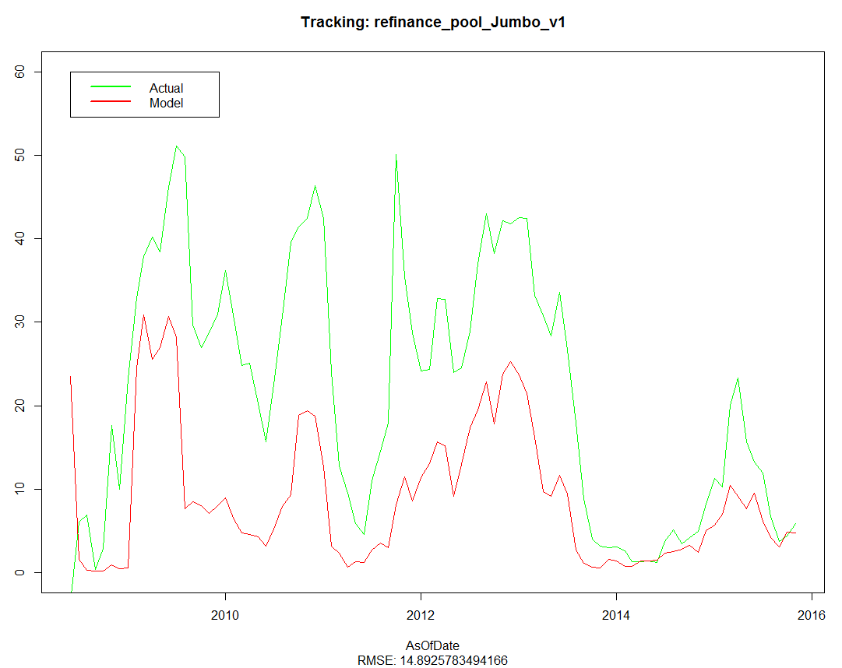

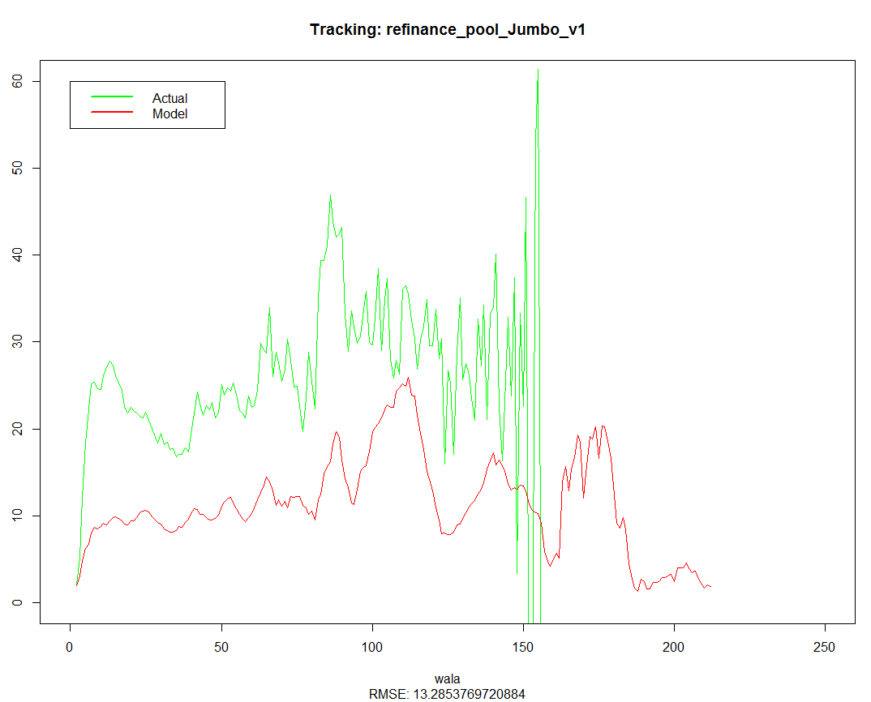
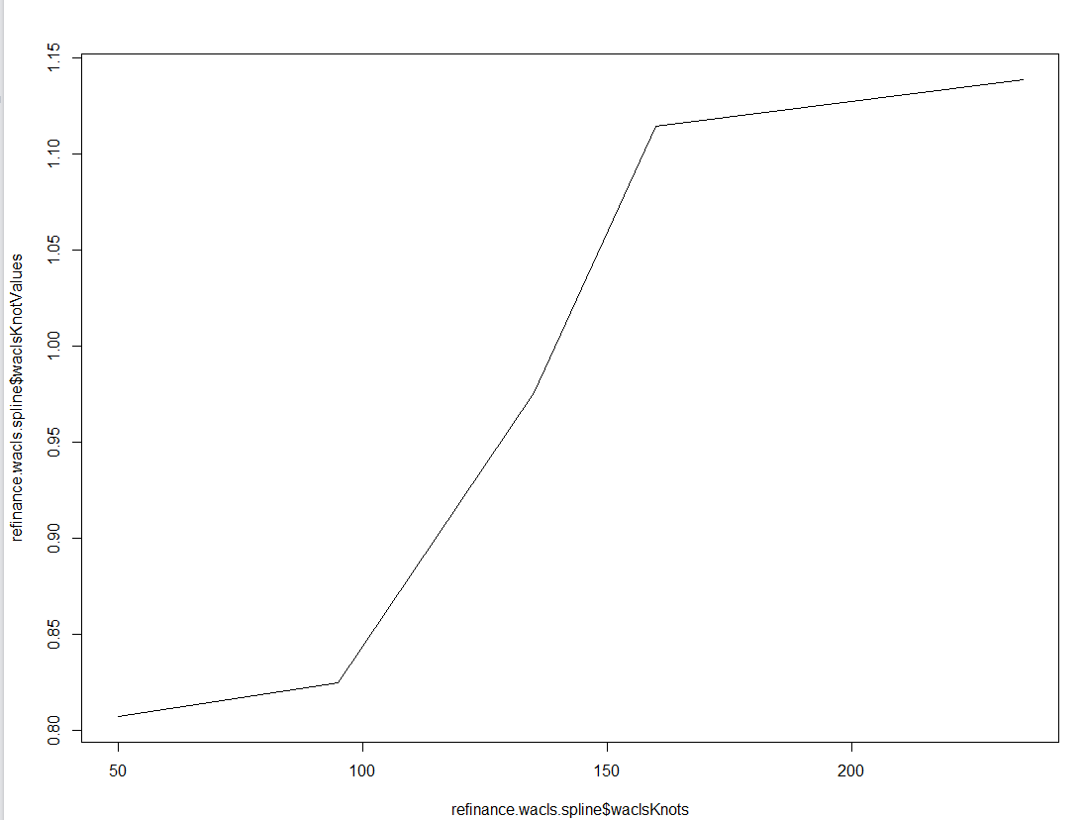
summary(wacls.multiplier)
Min. 1st Qu. Median Mean 3rd Qu. Max.
0.7986 1.1670 1.1700 1.1710 1.1740 1.2390

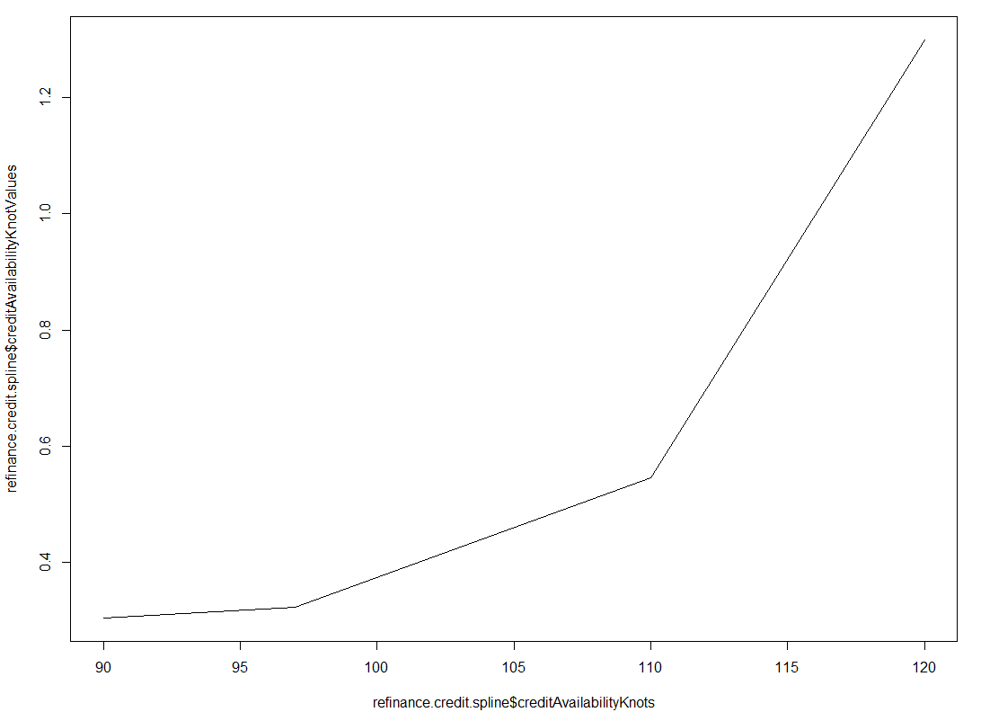
summary(credit.multiplier)
Min. 1st Qu. Median Mean 3rd Qu. Max.
0.2979 0.3141 0.4002 0.4427 0.5803 0.6304

Re-specified Loan Size
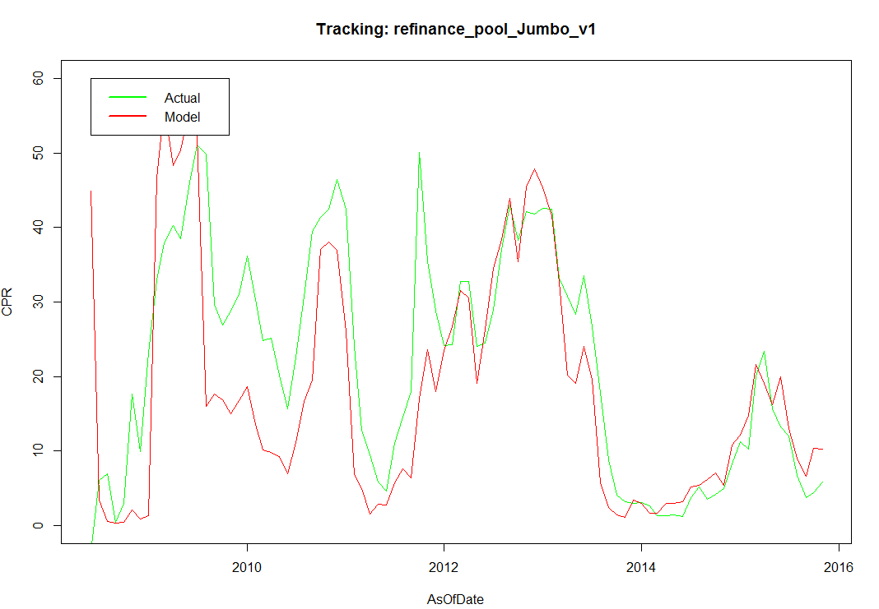

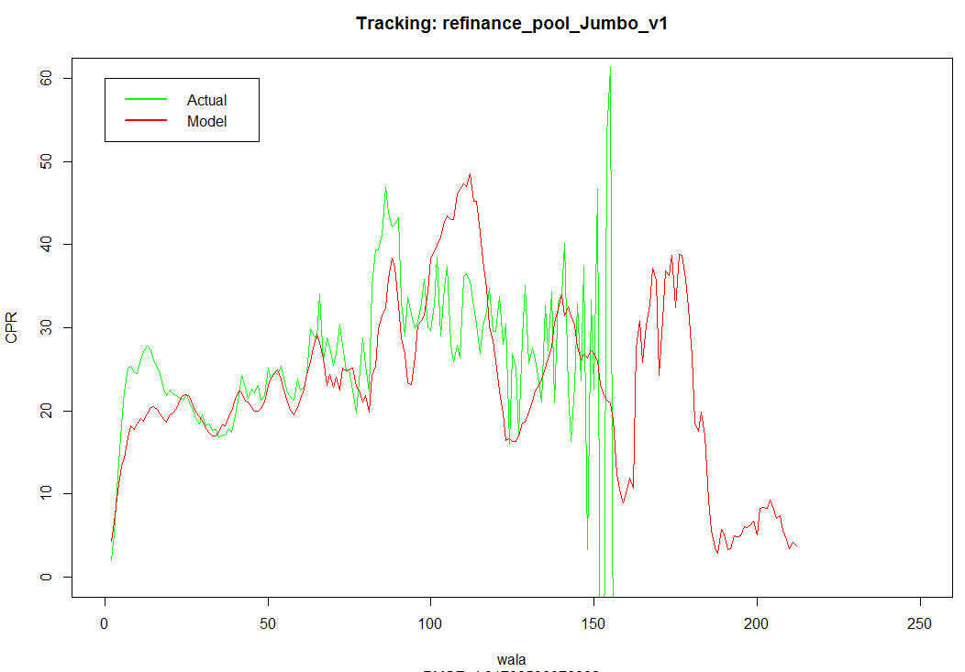

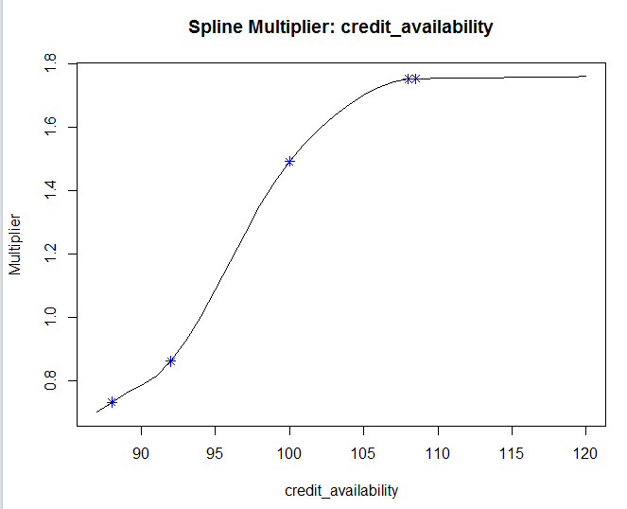
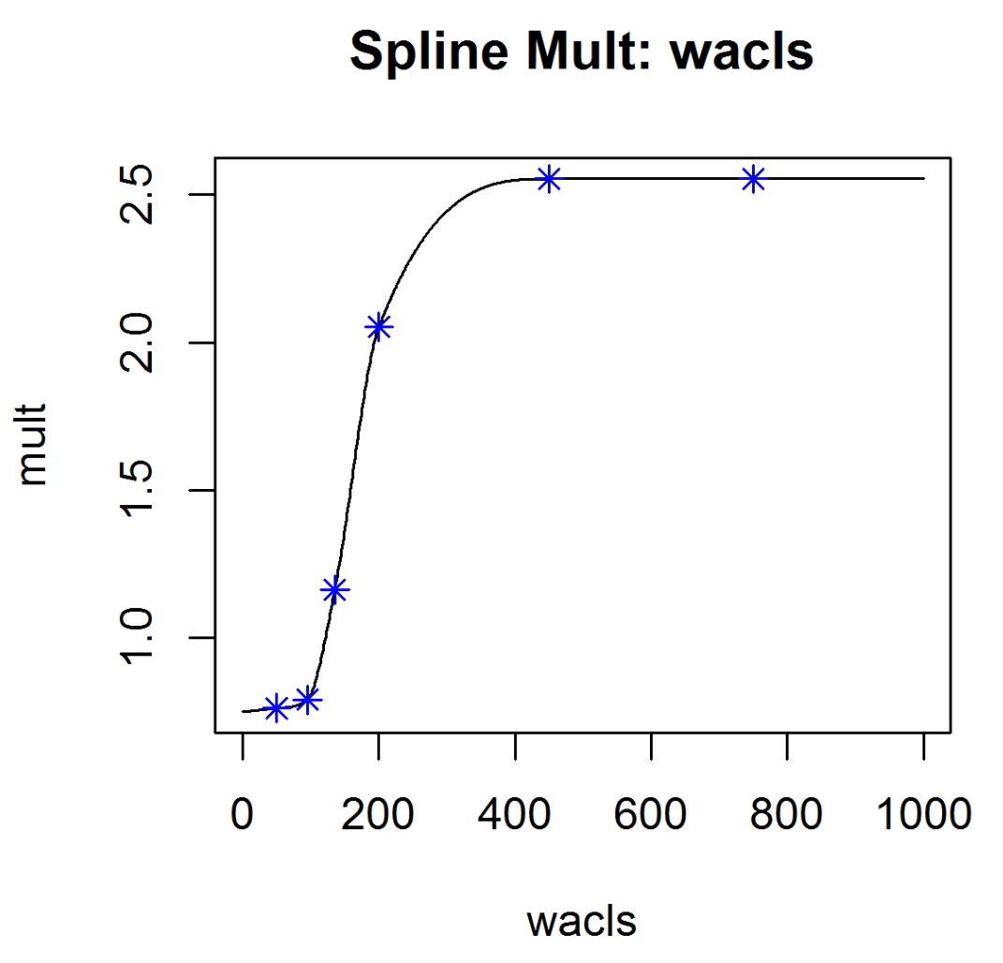

Jumbo Rate = WAC Spread + PMMS

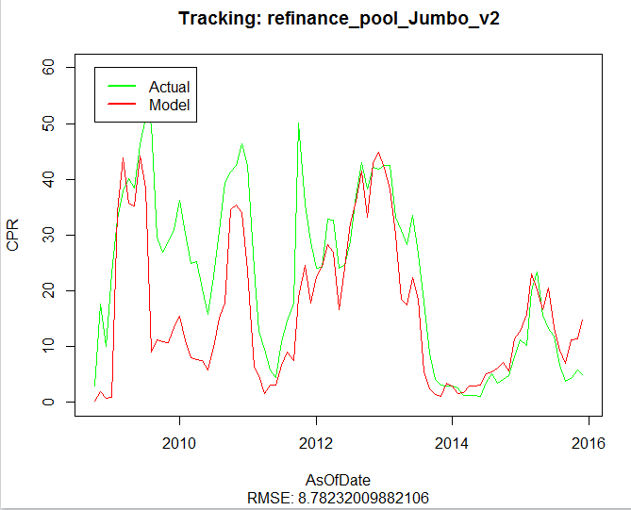
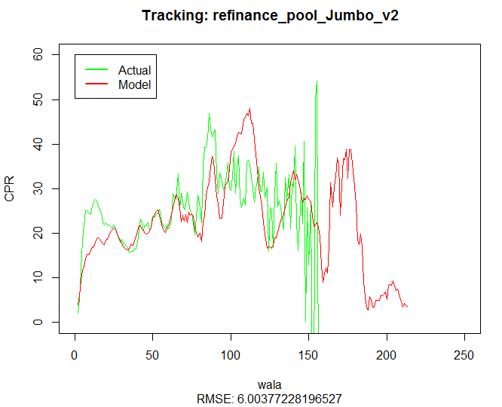

Credit Availability – for Jumbo dataset (12/09)
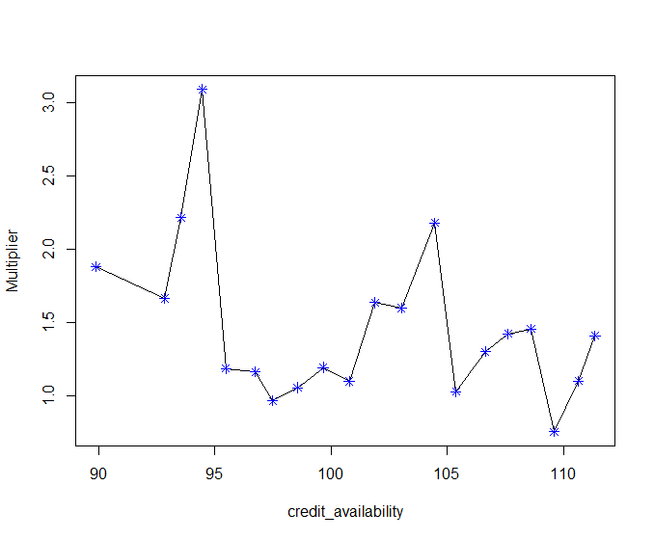
Tracking without credit availability
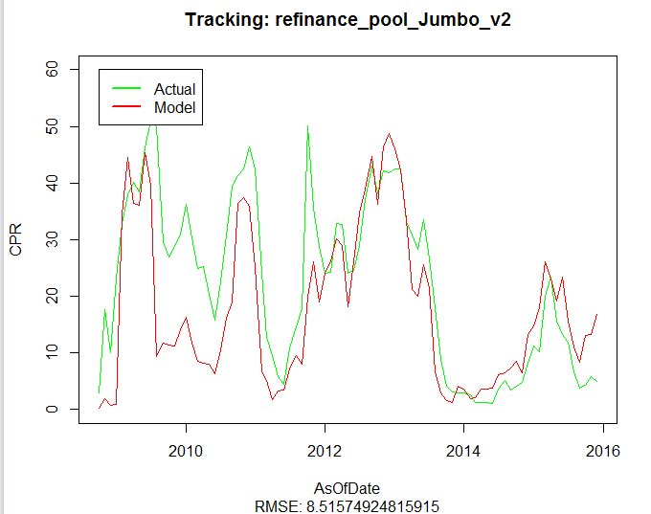

After using conventional refi-percentage to calculate Media Effect (12/10)
"refinance_model_mult_pool_all_20151209.json"
Without credit
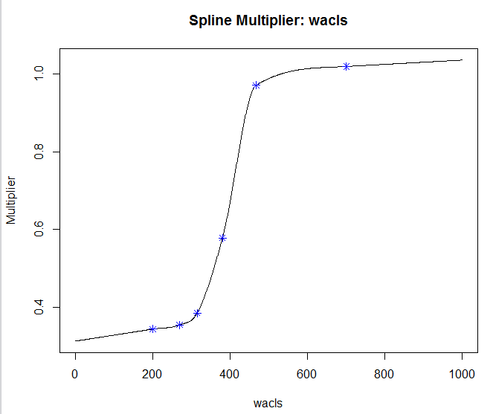

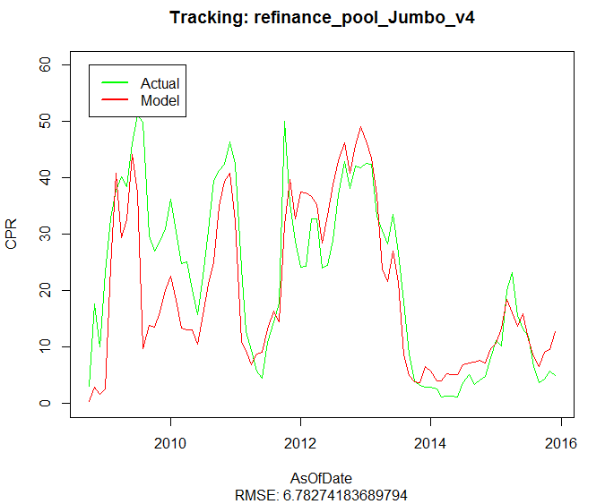

With credit.weighted.mean = 1.258188
